**TOT Flow**

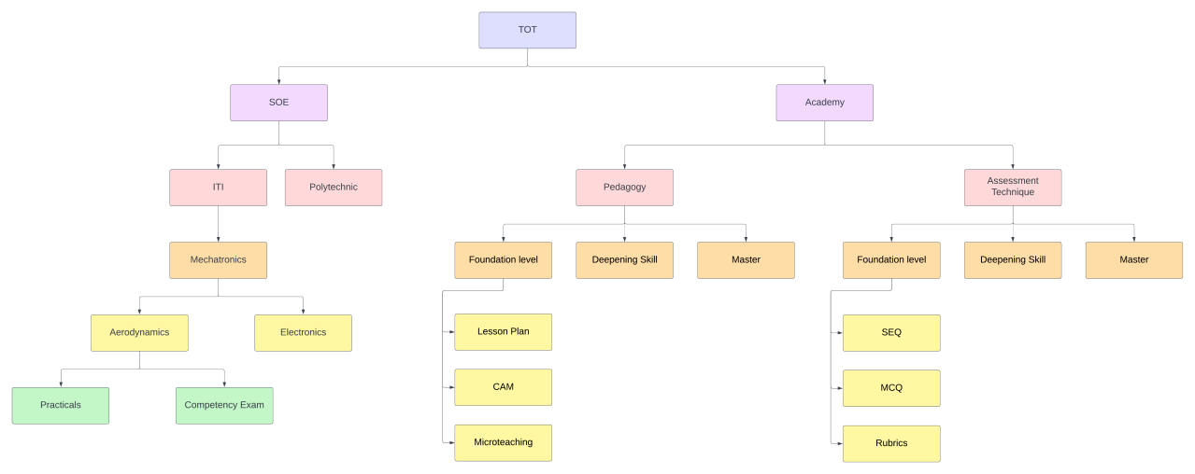

**School of Engineering(SOE):**

1. Participants of the program are faculties of different government organizations across Odisha
2. Faculties background are Polytechnic and ITI’s
3. The TOT skills participants for (SOE) could be following :

Polytechnic

1. Lecturers
2. Electrical
3. Mechanical
4. Electronics
5. Senior Lecturer
6. Lab Assistant
7. Princpials

ITI

1. Assistant Training Officers (ATO)
2. Training Officer (TO)

Principals

1. TOT Skills will have 4 courses:
   1. Mechatronics (MCE) - 8 modules
   2. Electrical (ET) - 6 modules
   3. Air Conditioning and Refrigeration(ACR) - 6 modules
   4. Mechanical Electrical Services(MES) - 7 modules
2. TOT duration will be either 5-6 days, 15 days or one month
3. Total duration of program is 40 hrs
4. Batch max size will be 40 candidates, the final list for which will be prepared by WSC from a list of DTET provided data.
5. WSC shares the list of participants with DTET so that the respective principles are directed to release their faculties for the 5-6 days program.
6. Course synopsis or curriculum is prepared by SOE for each course, which will mostly include less theories (2 out of 5/6) and more practicals (6 out of 18/20)
7. Participants can opt for hostel.
8. WSC (Assessment and Certification)
9. Practical - 100 marks (each practical assignment will have weight-age e.g. 20, 20, 20,etc) -

Continuous evaluation

MCQ - end of program evaluation = 30 marks

Passing marks - 50% (Practical plus MCQ)

100% attendance is a mandate for qualifying for the program

1. The certificate is pre-designed by WSC SOE. At the end of the program, the report will go to DTET. The report will be an indicator to let the DTET and respective Polytechnic and ITI principals know how many faculties have attended / not attended, scored well / failed, etc. Generation of certification is done by WSC Academy

**Academy:**

1. WSC Academy receives a letter from DTET with the list of participants
2. The Selected Trainee List is provided by DTET
3. Academy TOT has two courses: Pedagogy and Assessment Techniques
4. Peadagogy has fundamental level, Deepening Skill and Master (like basic, intermediate and advance)
5. Currently, WSC Academy does TOT 5 days program for Pedagogy - fundamental level
6. Once a batch completes the TOT program on fundamental level then it’s a mandate the same batch does TOT program on Assessment Techniques conducted by WSC Academy.
7. Pedagogy will include the following criteria :
   1. Lesson Plan (LP) - 50%
   2. Content Analysis Method (CAM) - 50%
   3. Microteaching - 50%
8. If a candidate scores less than 50% in any of the above then an online feedback session is conducted by WSC Academy where the trainer gives feedback and candidate re-submits the video
9. At the end of the program, certificate of participation is sent to the candidate via post